By: James Broadbent

PAT Phase1



Contents

Task Definition 2

User Story 2

Acceptance Test 3

Navigation/ Description of Flow Diagram 4

Screen Design 5

Input, Processing, Output (IPO) table and data validation 7

Task 1

### Task Definition

Geometry is a vital topic in mathematics for students to understand and apply from a young age. It develops a student’s logical thinking, deductive reasoning, analytical reasoning and problem-solving skills. During school, young students are losing focus, interest and curiosity about their work due to the outdated teaching methods in place. This causes these students to miss out on the understanding of their work and the development of their brains. The solution to this issue is to apply more modern teaching methods into the classroom by making use of video games to educate students. 24/7 GAMES provides a product which will allow young students to remain engaged, excited and interested as they gain a high-quality understanding about the basics of geometry while strengthening other areas of their brain, such as: hand-eye coordination, the ability to work within a timeframe and the speed to identify, analyse and make a decision.

### User Story

1. As a Teacher I would like to be able to increase or decrease the difficulty of the game so that I can ensure students are constantly being challenged while playing the game and that questions are asked once the level of that game is complete. I would also like the game to involve lots of colour so it looks exciting and fun.
2. As a Student I would like to be able to see my score at the end of a level so that I can see if I’m improving at my work. I would also like to being to learn about a large variety of shapes so that I can stay excited about the game.

Task 2

### Acceptance Test

* The system shall have multiple difficulties
* The system shall record and display the user’s current score
* The system shall randomly create objects from a large variety of shapes
* The system shall make use of a large variety of colours
* The system shall question the user after the level of the game is complete

Task 3

### Navigation/ Description of Flow Diagram

Begin

Main Menu Opens

End

Based Off The Button Clicked

About Menu Opens

Settings Menu opens

Game Screen Opens

### Avatar Selection Menu Opens

Difficulty Menu Opens

Tutorial Screen Opens

TASK 4

### Screen Design

## Main Menu:

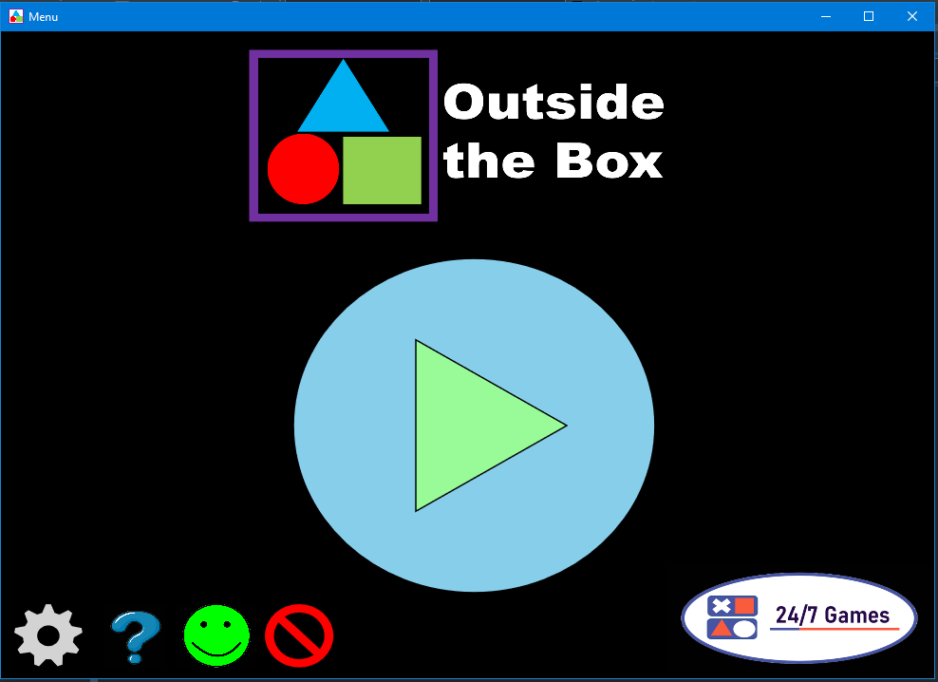

## Game Screen:

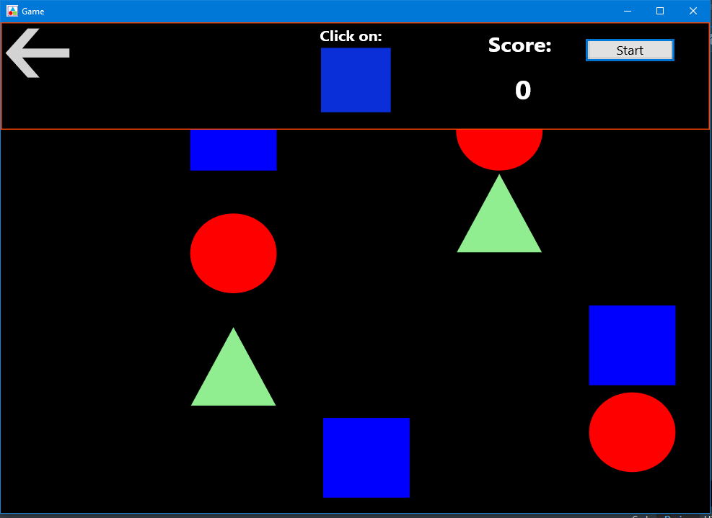

Task 5

### Input, Processing, Output (IPO) table and data validation

|  |  |  |  |  |
| --- | --- | --- | --- | --- |
| **Input** | | **Processing** | **Output** | |
| **Type of Input** | **Input validation** | **(TWO Algorithms / pseudo code)** | **Output component** | **Format of output** |
| **Username**  **Input component: InputBox/editbox** | **Test for an open field**  **Error message shown for an empty field** | **Processing item: Name**  **Algorithm:**  **If ‘Name’ = ‘ ’ then**  **Show error message**  **Else**  **‘Username’ = ‘Name’** | **Label** | **String/Text** |
| **Avatar**  **Input component: ComboBox** | **Only 1 input is able to be selected** | **Processing item: Avatar**  **Algorithm:**  **If ‘Avatar1’ is Selected then**  **‘Avatar’ = ‘Avatar1’**  **Else**  **‘Avatar’ = ‘Avatar2’** | **Image** | **Image** |
| **Score**  **Input Component: Shape** | **Only correct shape can change the Score** | **Processing Item: CorrectShape**  **If ‘CorrectShape’ = Clicked**  **Then ‘Score’ = ‘Score’ + 50** | **Label** | **Score/Numerical Value** |